# Key metrics

Metrics 

Annual return of stocks

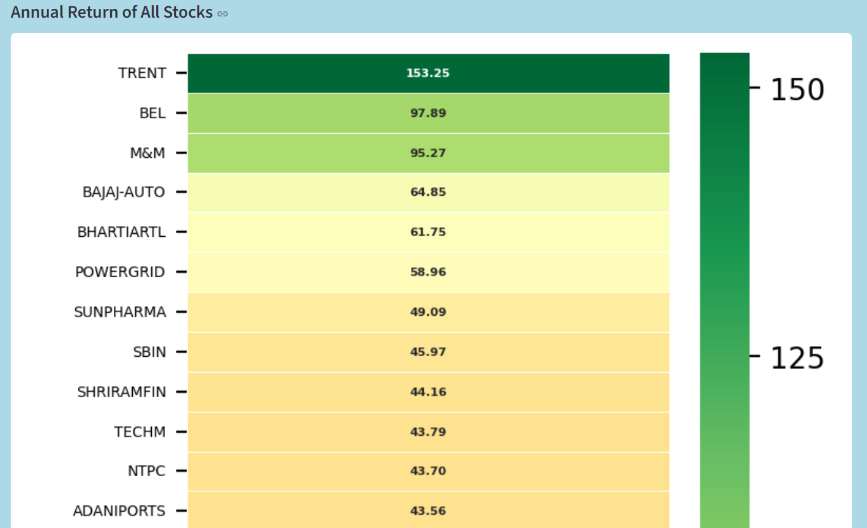

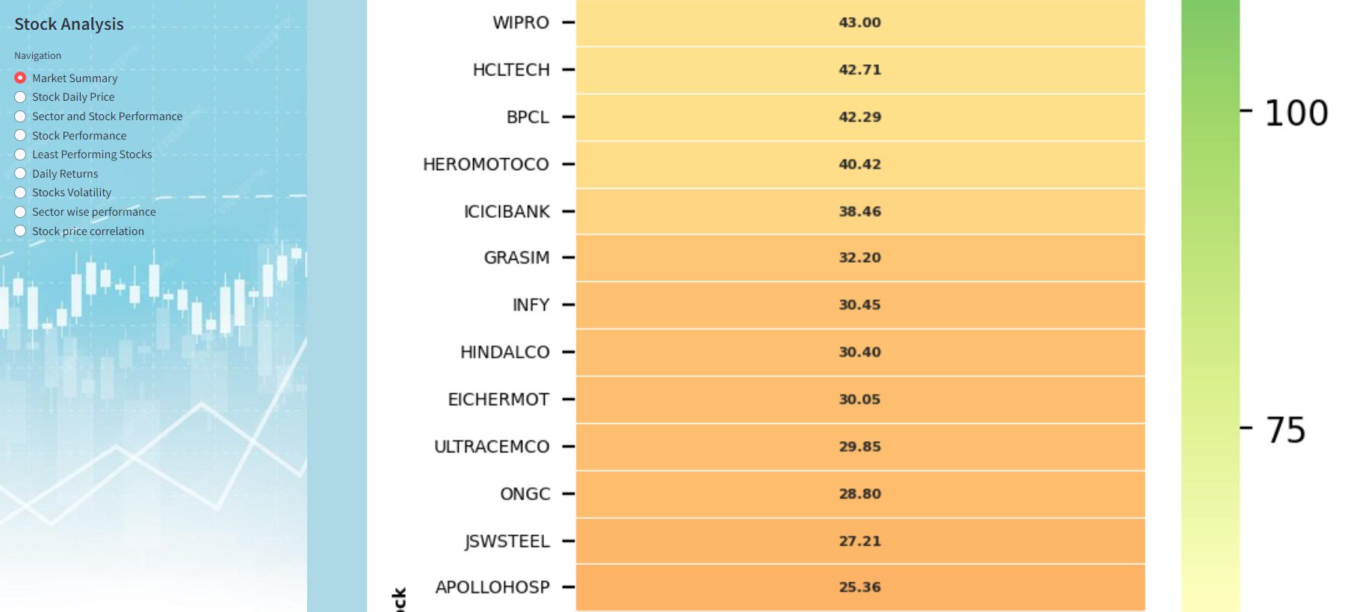

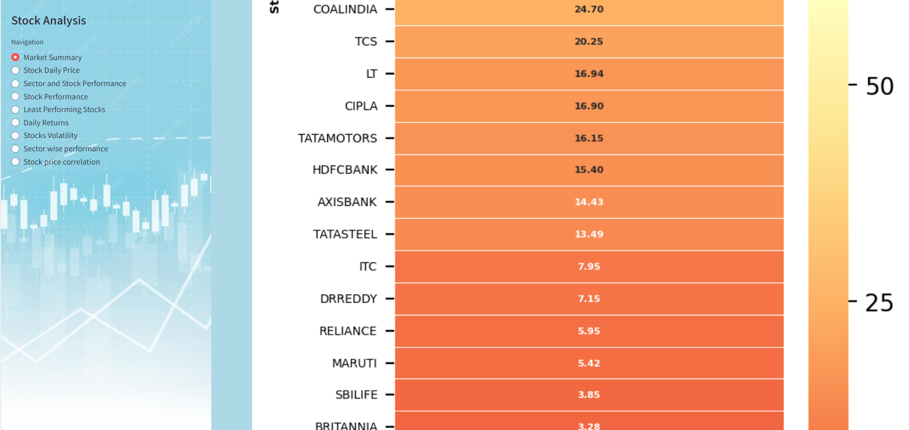

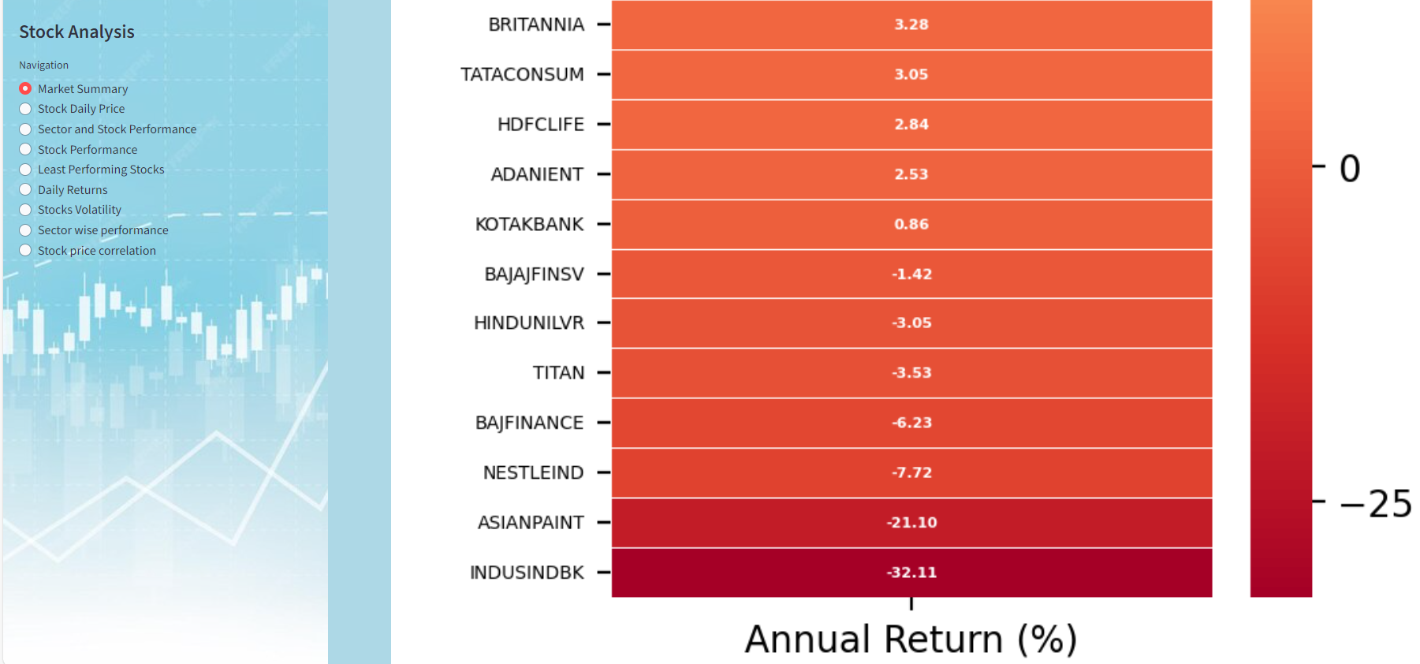

# Volatility Analysis

All stocks volatility

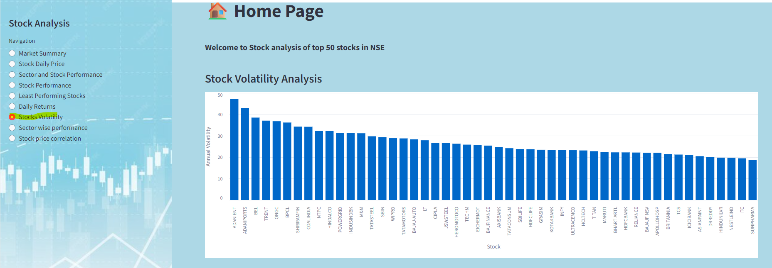

Top 10 volatile stocks 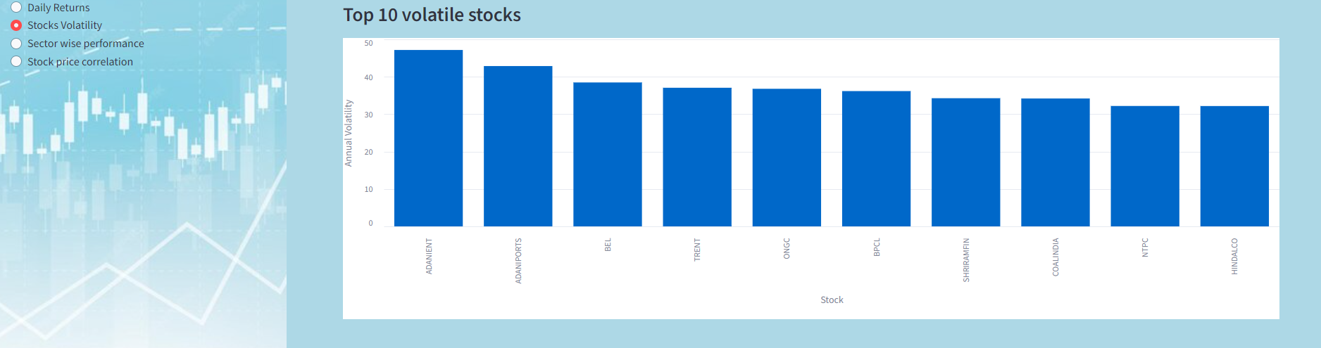

# Cumulative Return

Top 10 daily return in past one year 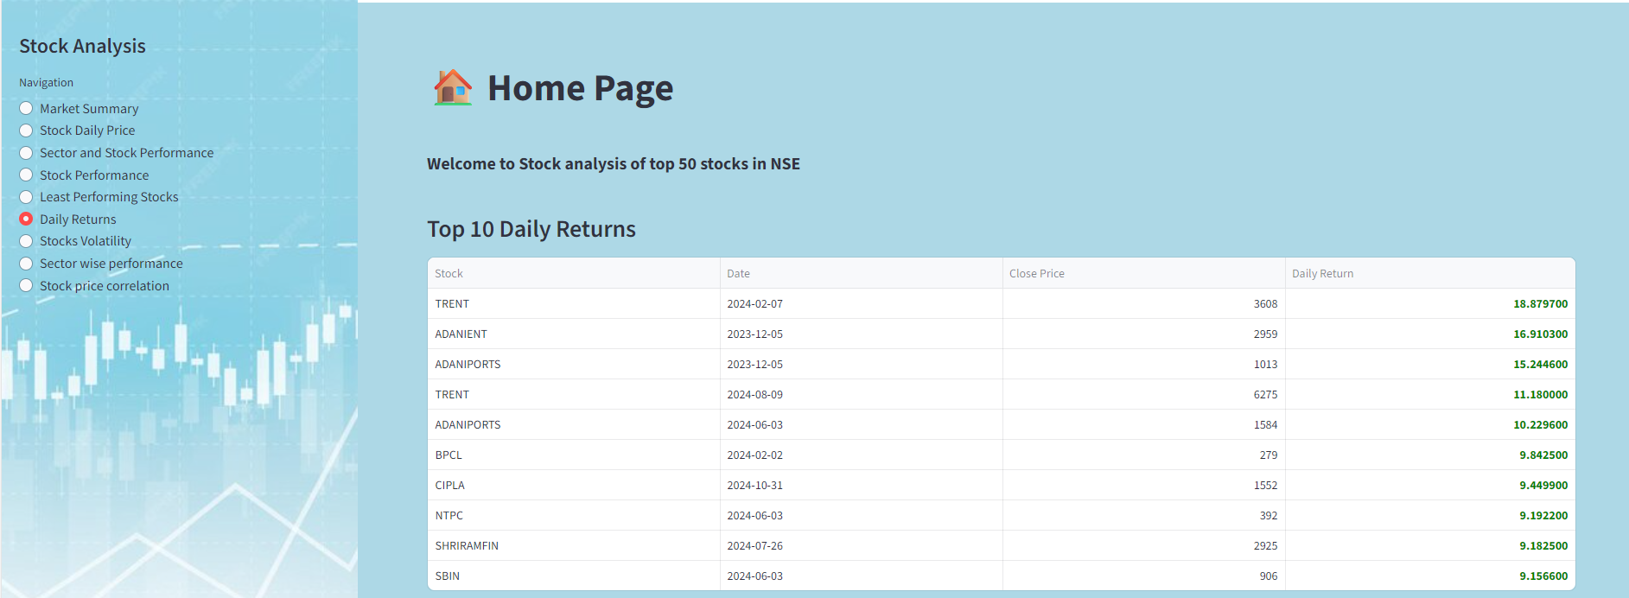

Stock wise Cumulative return 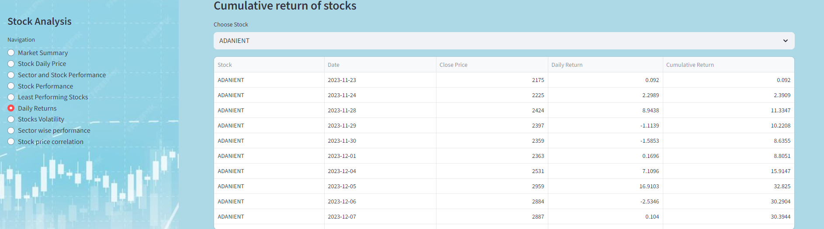

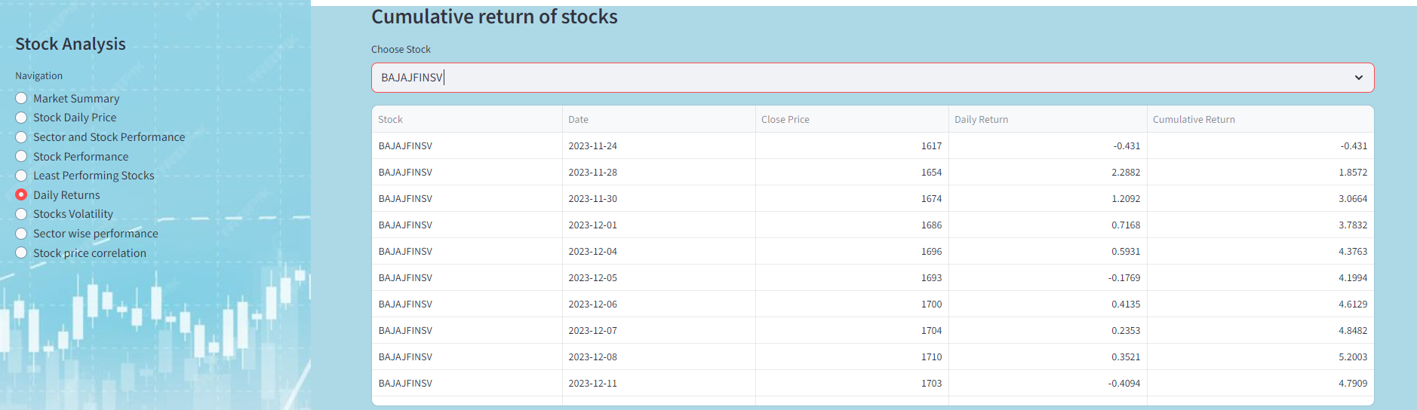

Top 5 cumulatively performing stock 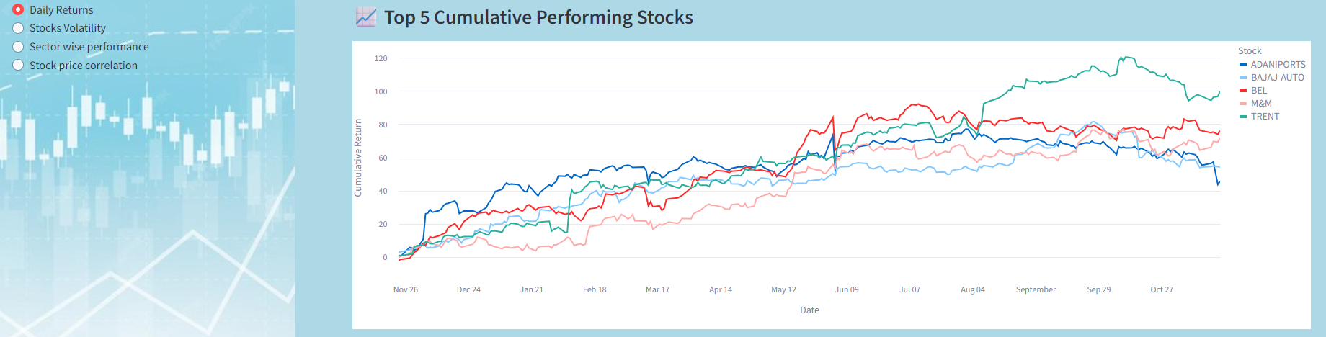

# Sector wise performance

Monthly return 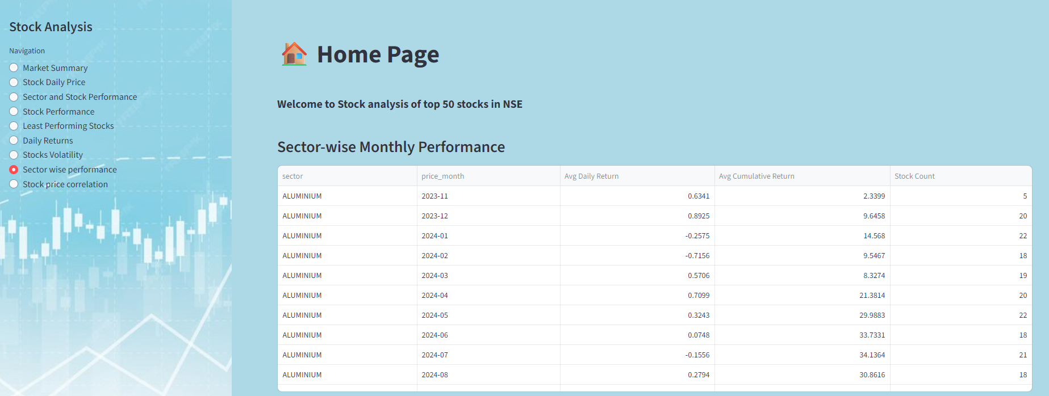

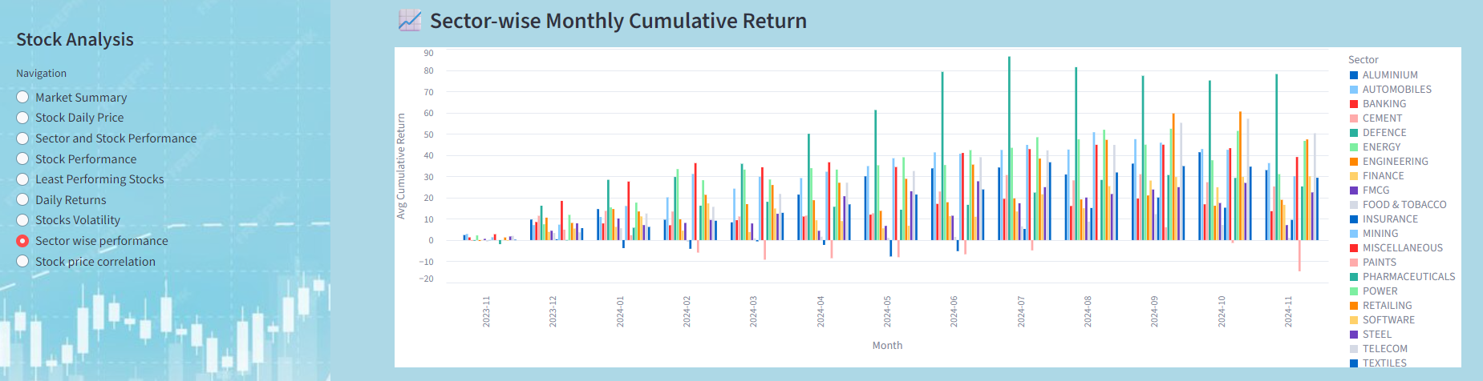

Average yearly return based on cumulative return calculation 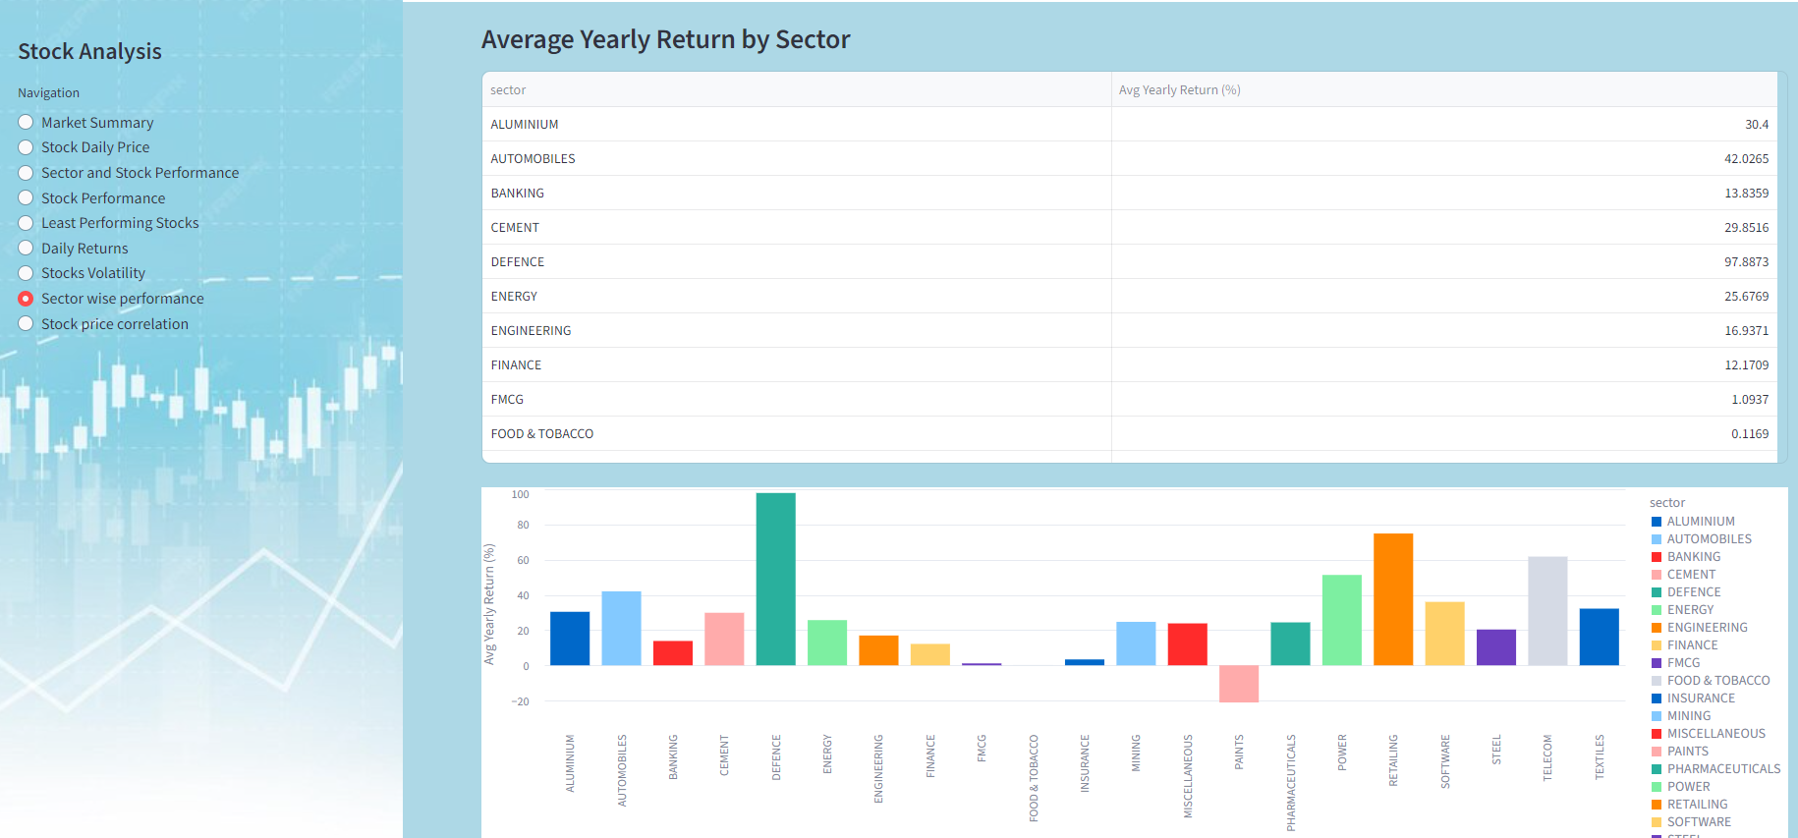

# Stock Price correlation

Correlation matrix 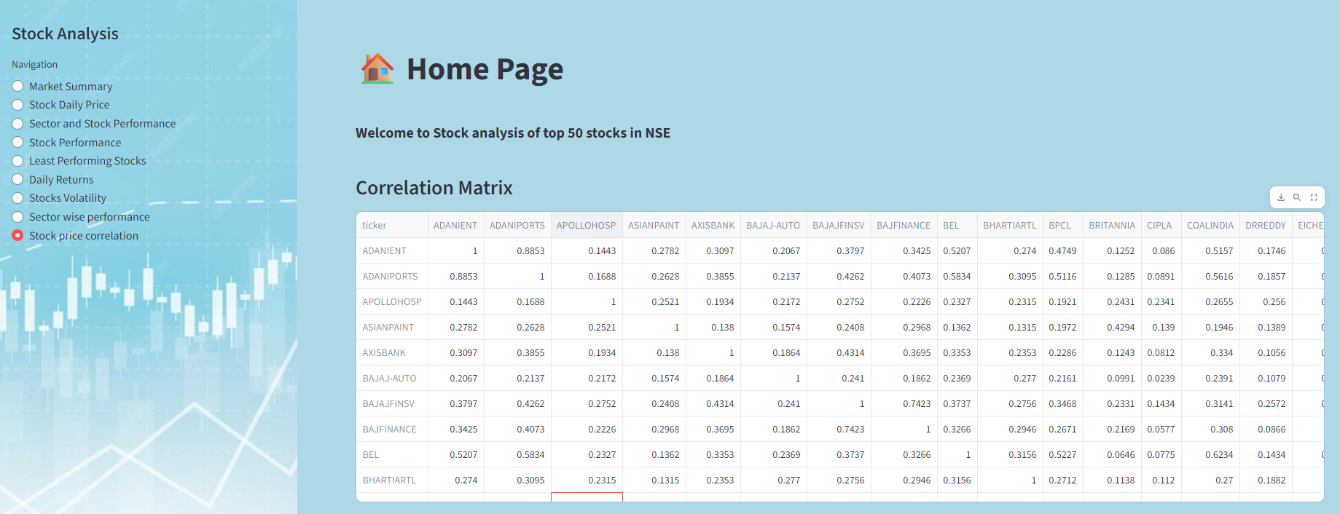

Correlation heat map 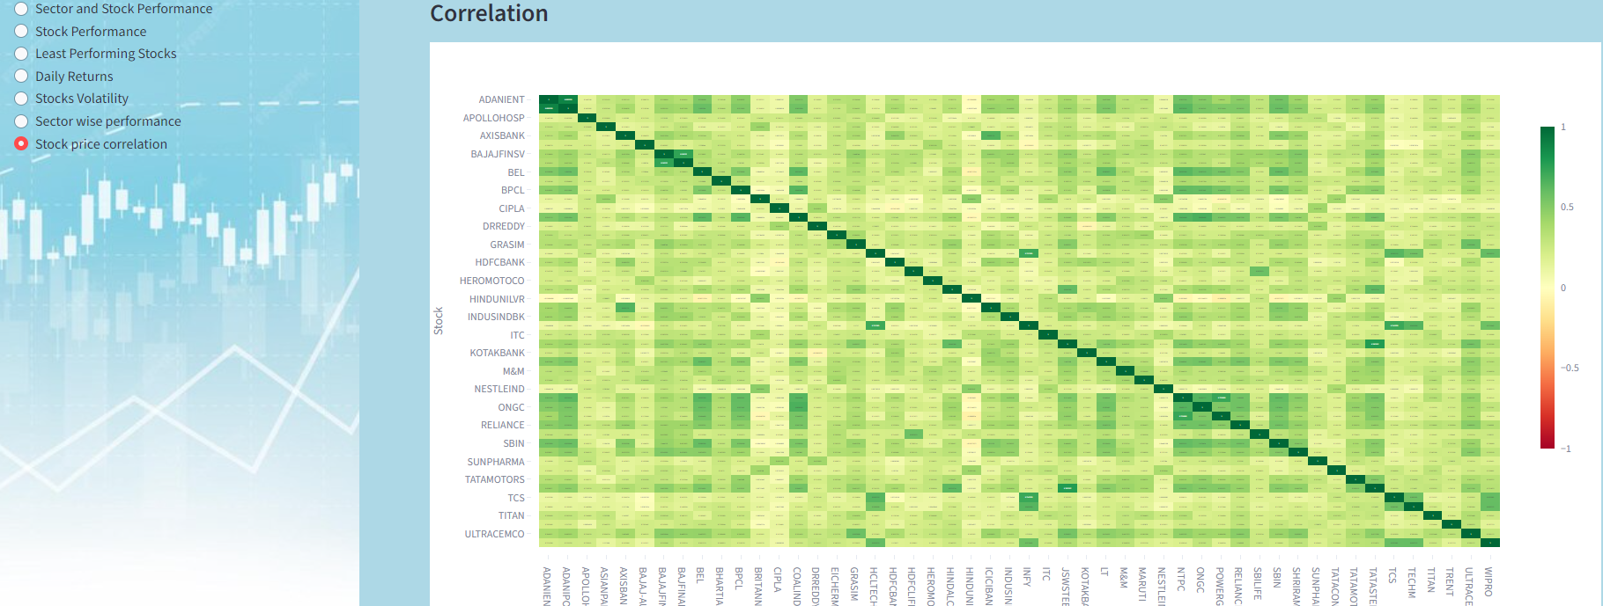

# Top 5 gainer and loosers ( Power bi)

## Top 5 gainers

April 2024 Top 5 gainers

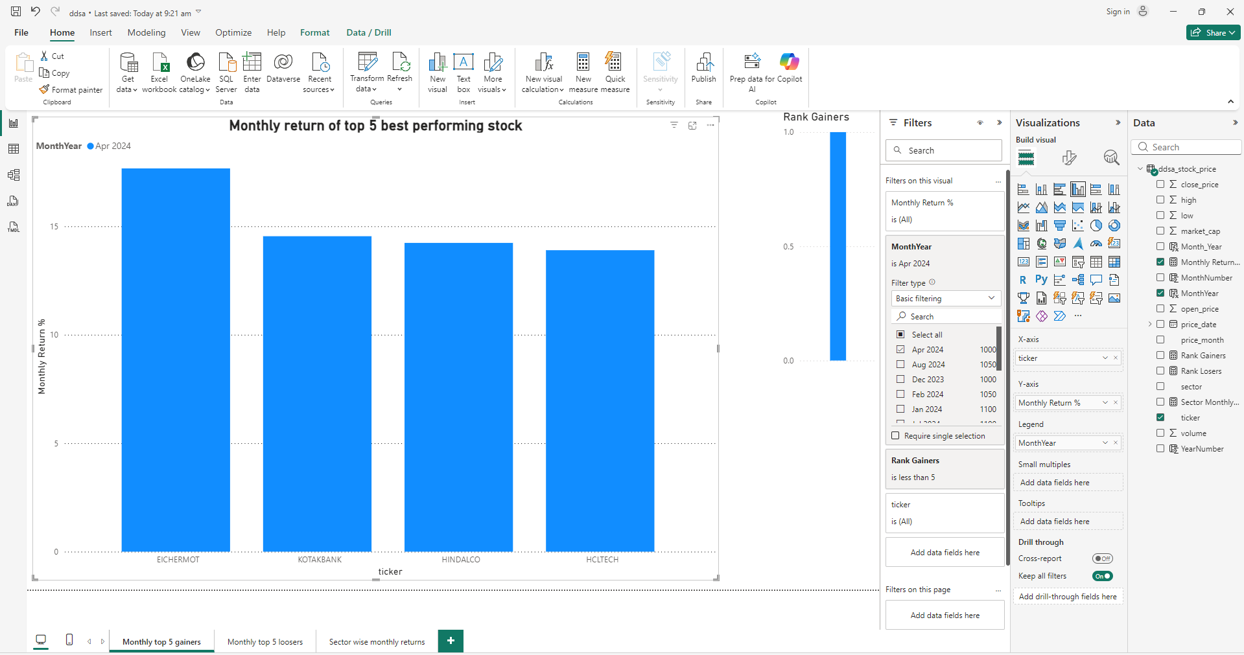

Feb 2024 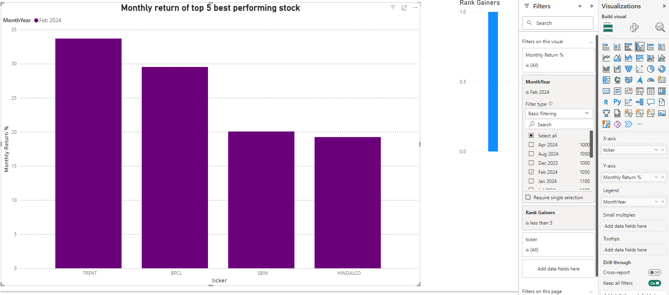

## Top 5 Loosers

Feb 2024 Top 5 loosers 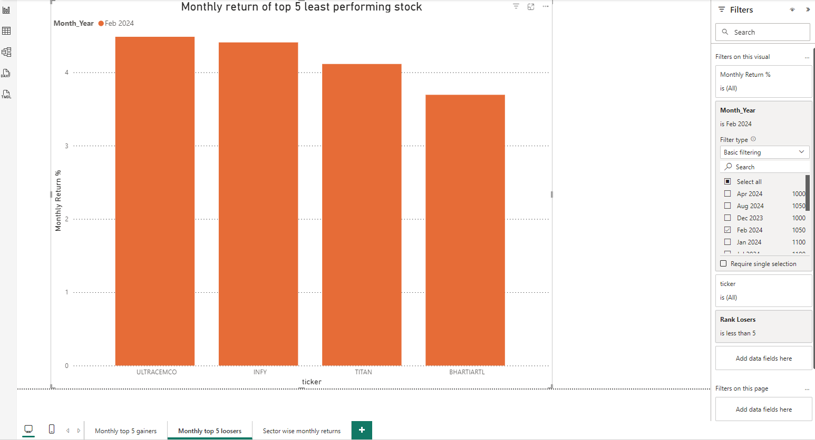

Oct 2024 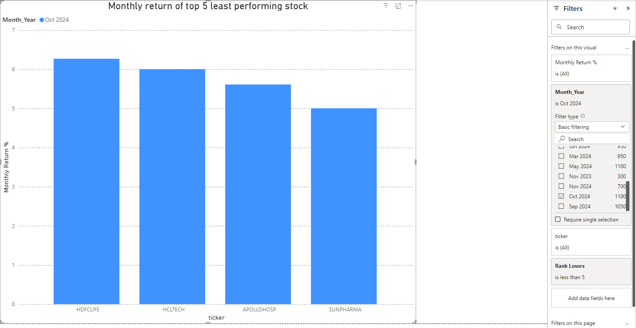

## Sector wise monthly return (Additionl)

Dec 2023 return

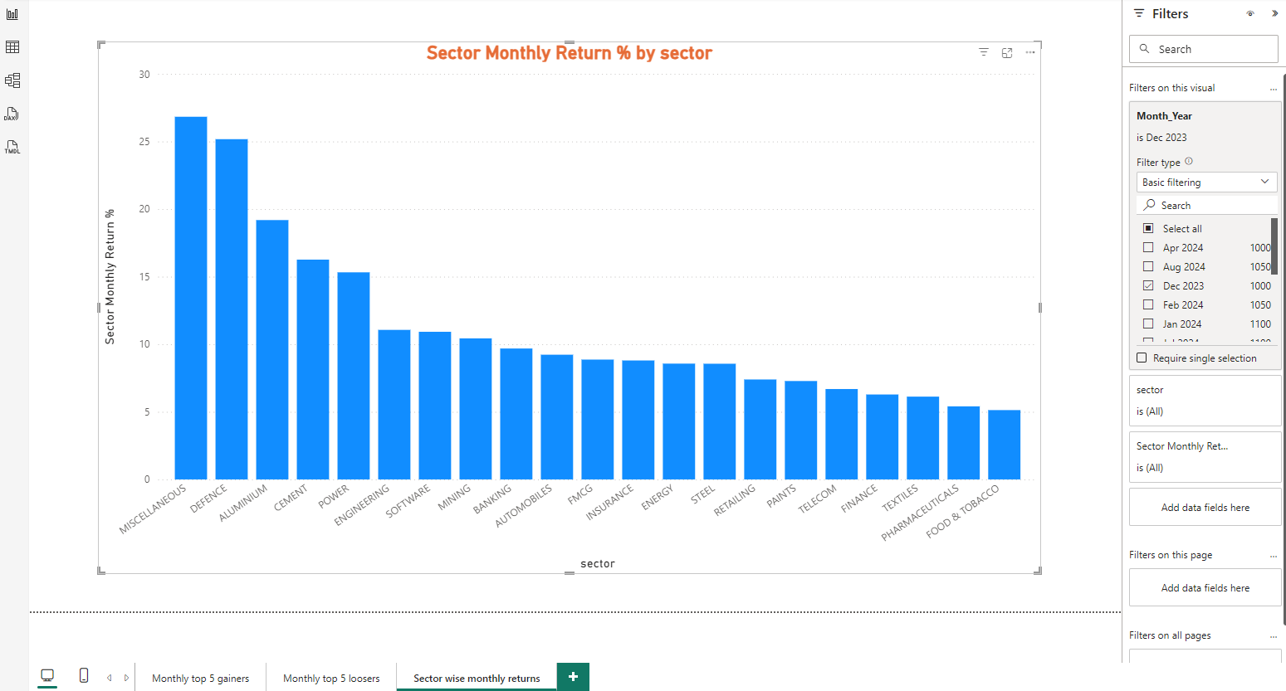

Aug 2024 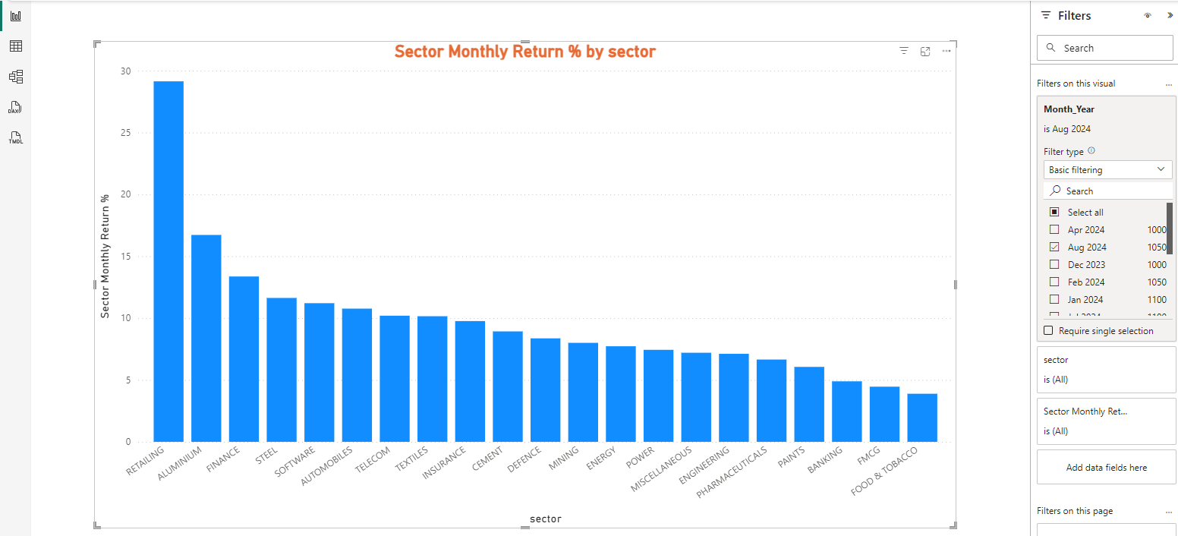

# Stock wise daily price ( Additional )

User can see the stock price for the date range. Filter can be done by stock and date range. 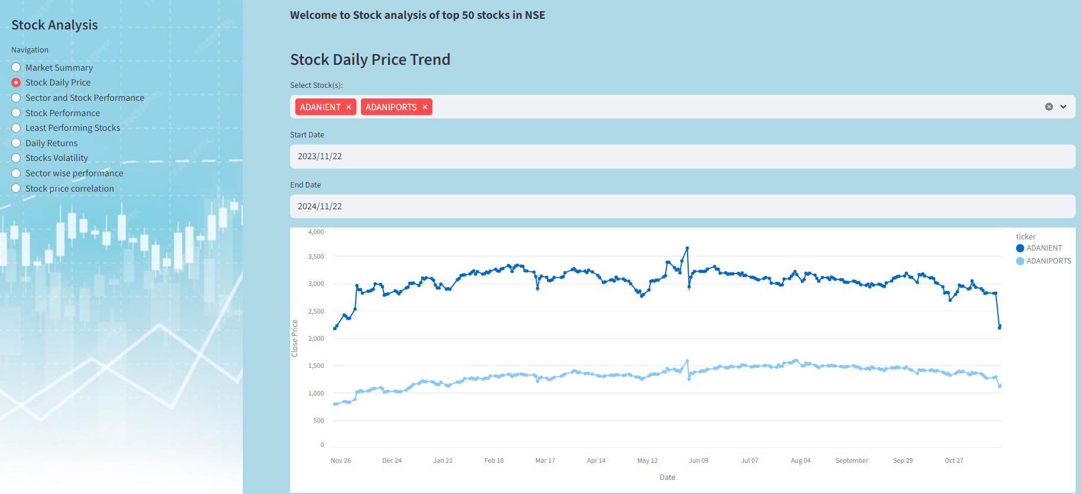

Bajaj stocks 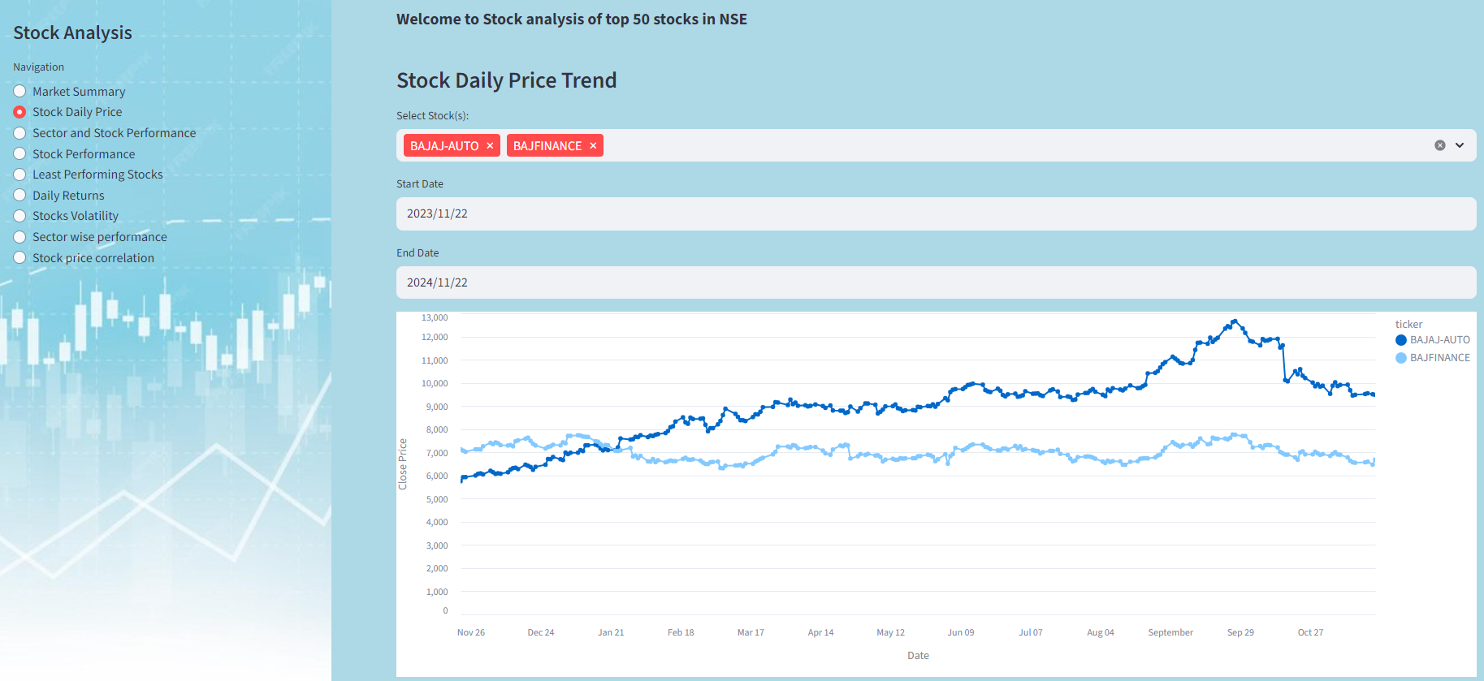

From Jan 1st to Nov 22nd 2024 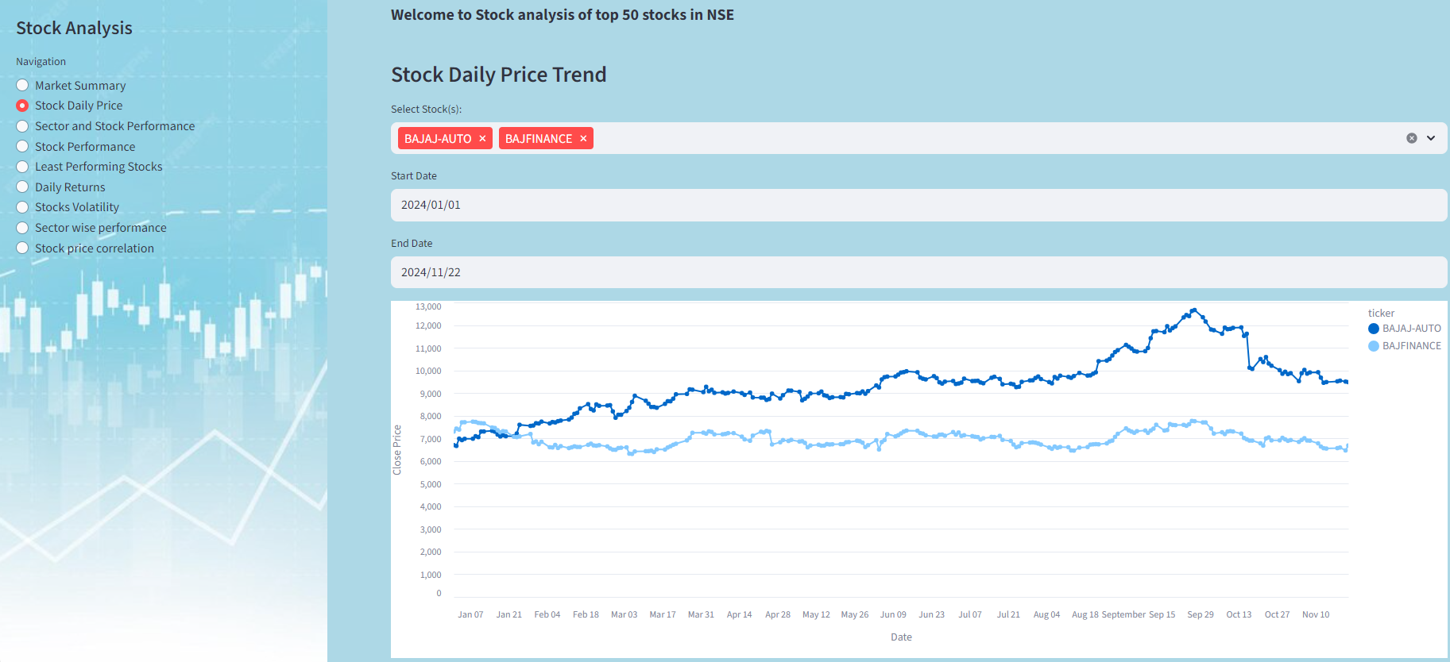

# Sector and stock performance ( Additional )

Sector wise return is shown 